**CONTENTS**

**1 INTRODUCTION**

1.1 Overview

1.2 Purpose

**2 LITERATURE SURVEY**

2.1 Existing problem

2.2 Proposed solution

**3 THEORITICAL ANALYSIS**

3.1 Block diagram Diagrammatic overview of the project.

3.2 Hardware / Software designing

**4 EXPERIMENTAL INVESTIGATIONS**

**5 FLOWCHART**

**6 RESULT**

**7 ADVANTAGES**

**8 APPLICATIONS**

**9 CONCLUSION**

**10 FUTURE SCOPE**

**11 BIBILOGRAPHY**

**12 APPENDIX**

**1. INTRODUCTION**

**1.1 Overview**

This project on Email Automation deals with problem like In industries, while conducting workshops, competitions etc. it is necessary to send bulk certificates to candidates that to with specific certificates for a specific candidate.  
  
Through this project, we can create a system that will automatically sends the certificates to candidates through email with a particular subject line and body of email. For this first we should store all the certificates of candidates in the same order as stored in the excel. All these certificates (Attachments) should have a common path except the last value. For this we used Email SMTP-POP3 VOB and Excel VBO.

**1.2 Purpose**

Email has become the main method of communication for businesses around the world. It is critical to so many parts of your organization, but sifting through the inbox takes up valuable time.

Many organizations look to automation for specific parts of their email operations in order to serve customers more efficiently and allow humans to focus on the messages only they can handle.

Automate’s RPA functionality features an intuitive drag-and-drop interface that lets IT and business users quickly and easily automate email actions without writing a line of code. Use Automate for email automation with your overarching enterprise automation strategy.

**2. LITERATURE SURVEY**

**2.1 Existing Problem:**

●Proper planning

One of the biggest problems with implementing RPA intelligent automation is picking the correct processes to get the best return on investment (ROI). Choosing processes that are primed for RPA automation should not be taken lightly and proper vetting from the RPA team, department management, IT staff, and possibly the compliance team is key. Everyone with a stake in the processes needs to have a voice to make sure all concerns are considered. This will ensure questions and buy-in happen early to bring the best RPA solution to production.

●Proper development

Being able to complete your automation development in a timely way is only part of the RPA journey. The development of your intelligent automation needs to work with RPA best practices, brought by someone like a certified implementation partner, to make sure the solutions are both efficient and robust. This includes best practices like proper retry loops, exception handling, and workflow management.

●Proper scheduling

Another common problem when implementing RPA automation is making sure you properly schedule all completed processes. They should be scheduled to run automatically to ensure tasks are completed as needed. This may mean determining when the process needs to run, how many digital workers (aka software robots) should be working on the process, and if RPA resources can be shared between processes on a regular basis. These are usually determined by the developer early in the process and should be confirmed by the business.

**2.2 Proposed Solution:**

In industries while conducting workshops, competitions etc. it is necessary to send bulk certificates to candidates that to with specific certificates for a specific candidate. Through this project, we can create a system that will automatically sends the certificates to candidates through email with a particular subject line and body of email. For this first we should store all the certificates of candidates in the same order as stored in the excel. All these certificates (Attachments) should have a common path except the last value. We will be using Email SMTP-POP3 VOB and Excel VBO.

**3. THEORITICAL ANALYSIS**

**3.1 Block diagram**

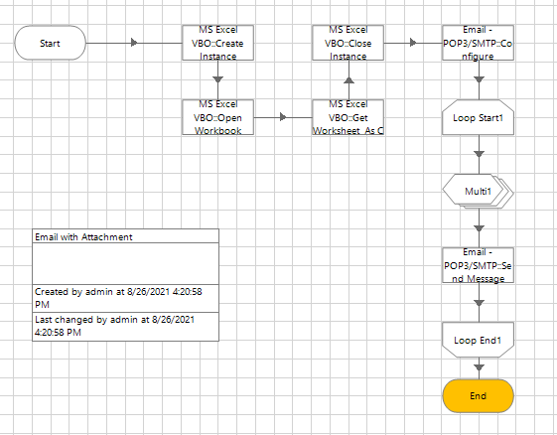

**3.2 Hardware / Software designing**

**Hardware Required:**

The following is the Hardware required to complete this project:

● Internet connection to download and activate

● Administration access to install and run Blue Prism

● Minimum 10GB free disk space

● Windows 8.1 or 10 (64-bit version only) OR Cloud: Get started free, *Cloud account required.

Minimum System Requirements To run Office Excel 2013, your computer needs to meet the following minimum hardware requirements:

● 500 megahertz (MHz)

● 256 megabytes (MB) RAM

● 1.5 gigabytes (GB) available space

● 1024x768 or higher resolution monitor

**Software Required:**

● Installation and Setup for Blue Prism

● Installation and Setup for MS Excel

**4. EXPERIMENTAL INVESTIGATIONS**

● Creating a Blue prism Process Model and binding it with a MS Excel VBO and Email VBO.

● Importing Blue Prism MS Excel VBO (Visual Basic for Applications)

● Importing Email VBO (Visual Basic for Applications)

● Binding Process Model with MS Excel VBO.

● Binding Process Model with Email VBO.

● Opening MS Excel Workbook.

● Specifying Blue Prism Stages to work on MS Excel Workbook in Prism.

● Tuning Process Flow with Blue Prism Actions.

● Closing MS Excel Workbook.

● Tuning Process Flow with Blue Prism Actions.

**5. FLOW CHART**

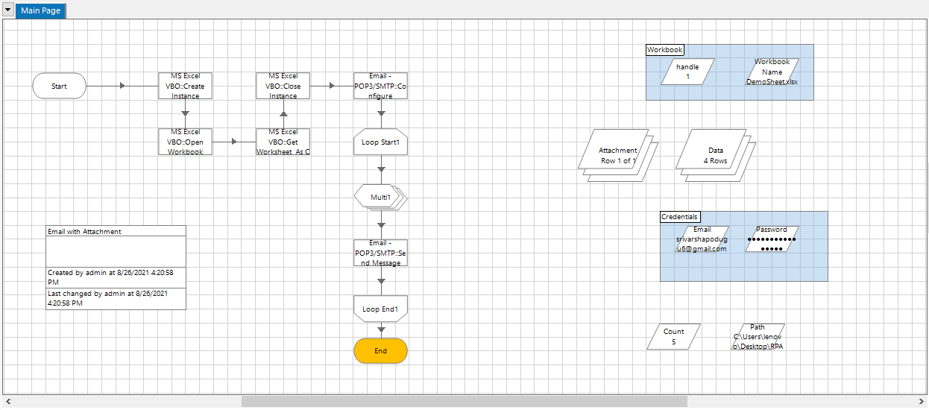

**6. RESULT**

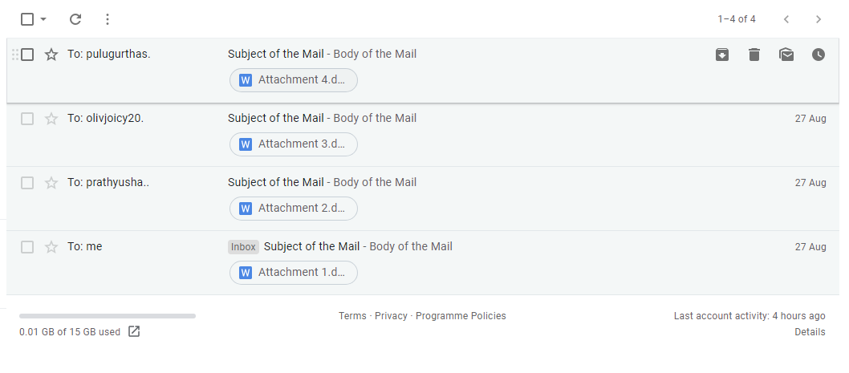

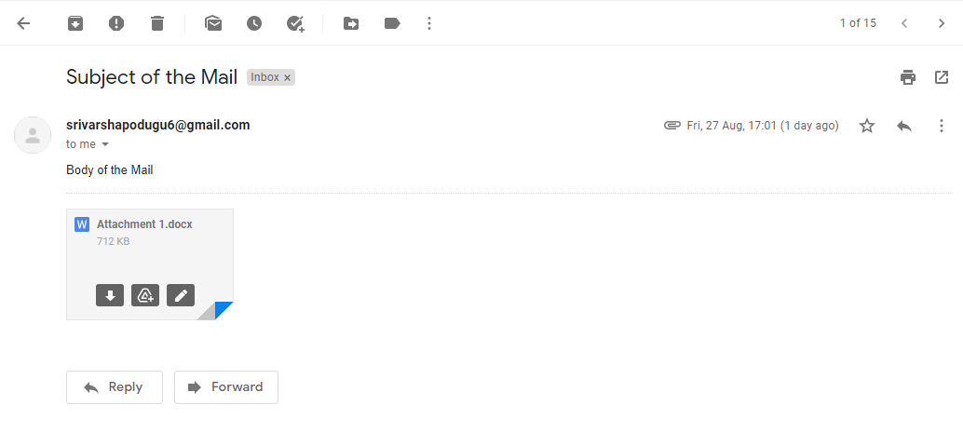

**7. ADVANTAGES**

**Advantages:**

* User-Interface Interaction
* Process Execution
* High volume Data Handling
* Increase Productivity
* Increase Efficiency
* Enhance Accuracy
* Increase Security
* It's automatic and doesn’t require intervention
* Nurture leads to make them more receptive
* Benefit your sales team
* Relevant to the email recipient
* Increase brand awareness
* Better personalisation for prospects
* Carefully planned email strategy
* Reduce the potential for errors
* Save time so you can focus on other tasks
* Reduce costs
* Boost business revenue
* Better targeting and segmentation
* Keep existing customers interested
* More detailed reporting
* Understand your customers more

**8 APPLICATIONS**

Automate outgoing email:

●In industries, while conducting workshops, competitions etc. we can send bulk certificates to candidates that to with specific certificates for a specific candidate.

●HR might need to email all employees within a certain region every other Tuesday to remind them to get their time off requests in before the end of the pay period.

●Sales support might need to generate and send a monthly sales report to each individual representative with their totals for the month.

●Customer Service might need to send individual emails to every customer confirming that a recurring order is about to ship. You can also set up bots to send emails based on triggers so that an email only sends if a certain activity happens.

**9 CONCLUSION**

It is significant for an organization to adopt RPA solutions to have a better insight into what their primary business goals are. If the available business processes and IT infrastructure are effective, then the business can consider RPA automation as a user-friendly tool to meet their automation objectives. Even if the process, platforms, and applications are outdated, then the RPA can be used to solve the issues. Overall, at this age of the digital transformation, robotic process automation is highly required for companies to nurture the healthy working environment.

**10 FUTURE SCOPE**

The robotic process automation is basically a software in which a robot is involved and used to perform human activities. These robots are used to carry out the organizational tasks and they are organized in such a way that they can manage any data or actions for the current applications which are used to carry out several business processes. The robots which are involved in RPA has to be trained and once they are trained, they can be automatically used to carry out the preferred functions. The operations which are automated involves a wide range of manipulation of data, activating responses and improving communications within several systems. The main objective of RPA is to decrease the need for the extra workforce, to carry out the large volume of IT jobs which are related to support the remote infrastructure, workflow, and other back-office processes related to the financial field, accounting, human resources, customer services and supply chain management. With RPA, it is possible to perform the work seamlessly, as it saves a lot of time and also helps to reduce the chances of human errors.The RPA software utilizes multi level features for data collection, configures the digital data and connecting it to a server or a website.

**11. BIBILOGRAPHY**

Willcocks, Leslie P. & Lacity, Mary & Craig, Andrew, 2015. "The IT function and robotic process automation," LSE Research Online Documents on Economics 64519, London School of Economics and Political Science, LSE Library.

**12. APPENDIX**

●First store the name and email address of the people in Excel

●Store the attachment to add in email in a folder

**Milestone 1**:

Importing VBOs

**Activity 1:** MS Excel VBO (Import VBO file) File -> Import -> Browse -> (C:\Program Files\Blue Prism Limited\Blue Prism Automate\VBO\BPA Object - MS Excel). Click Finish.

**Activity 2:** Email VBO (Import VBO file) File -> Import -> Browse -> (C:\Program Files\Blue Prism Limited\Blue Prism Automate\VBO\BPA Object - Email). Click Finish.

**Milestone 2:**

Configure the process

**Activity 1:** Create a process After launching the Blue Prism, Open Studio tab, right-click on process, and select Create process. The screenshots clearly explain the process of creating process.

**Activity 2:** Create an action stage, select MS Excel VBO from Business object drop down, select Create instance action. Create Data Item as follows, • type = number, • name =” handle”. Go to output tab and drag it into Store In column, click on ok.

**Activity 3:** Create an action stage, select MS Excel VBO from Business object drop down, select Open Workbook action. Create Data Item as follows, • type = text; name =” Workbook name”. Go to output tab and drag it into Workbook Name column, click on ok. In the input tab give the handle and path of the excel file.

**Activity 4:** Create an action stage, select MS Excel VBO from Business object drop down, select Get worksheet as collection. Create Collection with fields as follows, • type = text; name =” Name” • type = text; name= “Email”. Go to output tab and drag it into Workbook Name column, click on ok. In the input tab give the handle, workbook name and name of sheet in excel file.

**Activity 5:** Create an action stage, select MS Excel VBO from Business object drop down, select Close Instance action. Drag and drop the handle, give the file name, click on ok.

Activity 6: Add two data items 1. To store the Email • Name – Email • Type – Text • Initial value – Your email ID 2. To store the Password • Name - Password • Type – Password • Initial value – Password of your email ID

**Activity 7:** Create an action stage, select Email VBO from Business object drop down, select Configure action. In the input tab give the Email and Password and the give the following details: • POP3 Server = "pop.gmail.com" • SMTP Server = "smtp.gmail.com" • POP3 Port = 995 • SMTP Port = 587 • POP3 UseSSL = True • SMTP UseSSL = True Click on ok.

**Activity 8:** Add a loop stage and make it to loop for Data collection. Drag and drop a loop stage and change the arrangement of all the stages in the page, double click on it and in the collection drop down select data collection

**Activity 9:** Add two data items 1. To store the path of the attachment (only the constant path. For the numerical part we will be using calculation stage. • Name – Path • Type – Text • Initial value – constant values in the attachment path. 2. To store the number to increment the path for each attachment • Name – Count • Type – Number • Initial value – 1

**Activity 10:** drag and drop a collection, rename it as Attachment and give the following as initial fields • Name – Path; type – Text Create a row in initial values column.

**Activity 11:** Add a multi calculation stage to store the path to Attachment collection and to calculate path. Drag and drop a multi calculation stage, double click on it and add the following: • Calculate the path and store it in Attachment collection. • Increment count.

**Activity 12:** Create an action stage, select Email VBO from Business object drop down, select Send message action. In the input tab give the following details: • From = Email data item • To = Email from data collection • Subject = The subject you want to send • Body = The body you want to send • Attachment = Attachment collection Click on ok.

**Activity 13:** Link all the stages and run the bot at different timings to notice getting login to different classes. Do Proper connections (Links).

**Activity 14:** Testing the Process Object from Object Studio Click on Main Page, click on the Green play button to run the ‘Web Automation T2 Process’ Process object. It shows COMPLETED when there is no error or no failure in the object.

Click on the Main Page, click on the Reset button to reset the cache to rerun the process object as fresh.